# **Benefits of buying negative Google reviews**

Are you tired of seeing your competitors soar above you in the Google rankings? Do you wish there was a way to gain an edge and level the playing field? Well, what if I told you that [**buying negative Google reviews**](https://usukshop.com/product/buy-negative-google-reviews/) could actually be beneficial for your business? Yes, you read that right! In this blog post, we will explore how negative thoughts can inspire improvement, help beat other competitors, and why you should consider buying them. So buckle up and get ready to discover a whole new perspective on online reputation management!

## **Negative reviews inspire improvement.**

Negative reviews may initially seem like a blow to your business's reputation, but they can actually be a powerful catalyst for improvement. When customers leave negative feedback, it provides valuable insights into areas where your business may be falling short. These critiques highlight specific pain points and give you an opportunity to address them head-on.  
  
By embracing negative reviews, you demonstrate that you are open to feedback and committed to making necessary changes. This level of transparency builds trust with both existing and potential customers. It shows that you value their opinions and are dedicated to providing the best possible experience.  
  
Negative reviews also serve as a reality check. They help businesses recognize blind spots or issues they may have overlooked internally. Sometimes, when we become too invested in our products or services, we need to see flaws or areas for improvement. Negative feedback acts as a wake-up call, pushing us out of our comfort zones and forcing us to reevaluate our strategies.  
  
Moreover, negative reviews provide an opportunity for engagement with disgruntled customers directly. By responding promptly and sincerely addressing their concerns publicly on platforms like Google Reviews, you not only resolve the issue at hand but also showcase your commitment to customer satisfaction.  
  
In essence, negative reviews inspire growth by shining a light on areas in need of improvement while simultaneously showcasing your dedication towards customer satisfaction and building trust within your target audience. So, instead of shying away from negative feedback, embrace it as an invaluable tool for progress!

## **Negative Google reviews can help beat other competitors.**

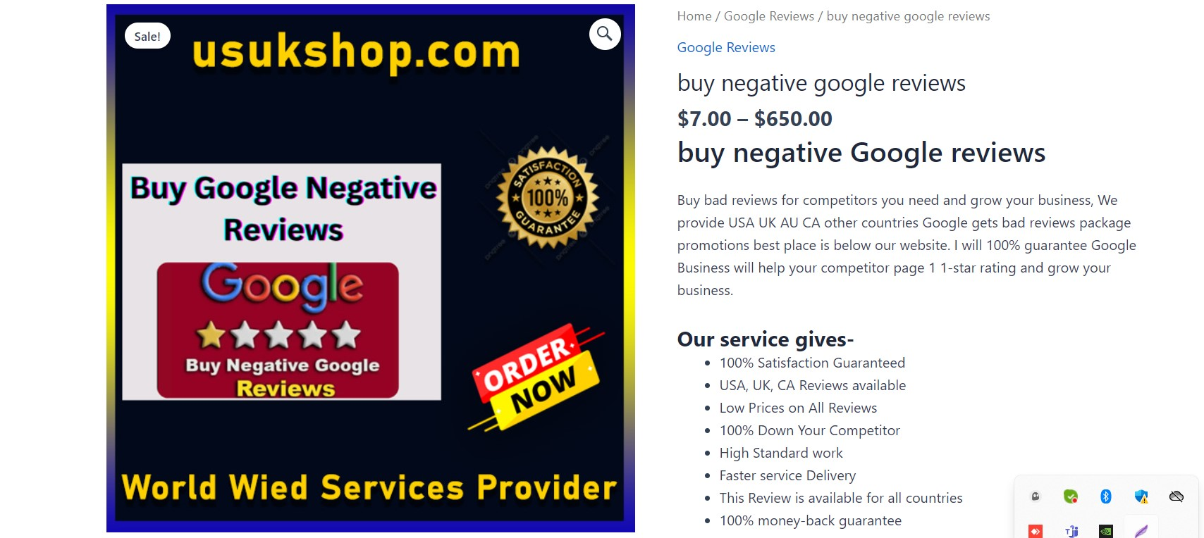

One of the significant [**benefits of negative Google reviews**](https://usukshop.com/product/buy-negative-google-reviews/) is that they can help beat other competitors in the online marketplace. In today's digital age, where customer feedback holds immense power, having a few negative reviews can actually work to your advantage.  
  
Negative reviews provide valuable insights into areas where you may be falling short. By analyzing these critiques and identifying common pain points, you gain practical knowledge about what needs improvement within your business. This feedback allows you to make necessary adjustments and enhancements to your products or services, ultimately increasing customer satisfaction.  
  
When potential customers come across negative reviews for your competitors while researching their options, it automatically positions you as a more reliable choice. Customers view businesses with a mix of positive and negative reviews as more genuine and trustworthy than those with only positive feedback. This gives you an edge over your competition by highlighting any perceived weaknesses in their offerings.  
  
Furthermore, responding professionally and constructively to negative reviews demonstrates excellent customer service skills. It shows that you value each customer's experience and are actively working towards resolving any issues they may have encountered. This level of engagement not only helps retain existing customers but also attracts new ones who appreciate transparent communication.  
  
Negative Google reviews can play a crucial role in creating differentiation between businesses within the same industry or niche market. Embracing constructive criticism rather than fearing it will allow you to continually improve while positioning yourself ahead of competitors who shy away from addressing their shortcomings head-on.

## **For what reason should you buy negative reviews?**

For what reason should you buy negative reviews? While it may seem counterintuitive, purchasing negative Google reviews can actually benefit your business in several ways. Negative reviews provide valuable feedback that can inspire improvement and help you beat out competitors.  
  
Negative reviews serve as a source of honest feedback from customers. They highlight areas where your business may need to catch up or where improvements could be made. By addressing these concerns and making necessary changes, you have the opportunity to enhance your products or services, ultimately improving customer satisfaction.  
  
Moreover, negative Google reviews can give you a competitive edge. In today's digital landscape, potential customers often compare different businesses before making a purchase decision. Having some negative reviews alongside positive ones portrays authenticity and transparency. It shows that your business is fearless in acknowledging its shortcomings and is actively working towards betterment.  
  
Additionally, buying negative reviews allows you to strategically position yourself above competitors who may have only positive ratings. Customers are more likely to trust businesses with a mix of both positive and negative feedback because it appears more genuine.  
  
[**By purchasing negative Google reviews**](https://usukshop.com/product/buy-remove-negative-reviews/) from reputable sources like ours (insert company name), you can ensure that they are written realistically without appearing fake or malicious. This helps maintain credibility while reaping the benefits outlined above.  
  
Buying negative Google Reviews provides an avenue for growth by inspiring improvement within your business and helping you stand out from competitors with only positive ratings. Embracing constructive criticism demonstrates authenticity and gives potential customers confidence in choosing your brand over others.

## **Why will you buy negative reviews from us?**

Why should you choose to buy negative reviews from us? Well, there are a few key reasons why our services stand out from the competition.  
  
We understand the importance of authenticity. When you purchase negative Google reviews from us, they will be carefully written by experienced professionals who know how to mimic genuine customer feedback. This attention to detail ensures that your negative reviews appear realistic and believable.  
  
Our team is well-versed in SEO strategies. We know just how crucial it is for businesses to maintain a strong online presence. By strategically placing these negative reviews amidst your positive ones, you can create a more balanced profile on Google's search results page. This can help boost your website's visibility and organic traffic.  
  
We pride ourselves on providing excellent customer service. Our dedicated support team is available round-the-clock to address any concerns or questions you may have throughout the process of buying negative reviews.  
  
So, if you're looking to enhance your online reputation and gain a competitive edge over other businesses in your industry, consider purchasing negative Google reviews from us today!

## **Conclusion**

Conclusion  
  
In today's competitive digital landscape, negative Google reviews are often seen as detrimental to a business's reputation. However, when approached with the right mindset and strategy, there are actually several benefits to buying negative reviews.  
  
Negative reviews inspire improvement. They provide valuable insights into areas of your business that may need attention or enhancement. By addressing these issues and making necessary improvements, you can ultimately enhance customer satisfaction and loyalty.  
  
[**Negative Google reviews**](https://usukshop.com/product/buy-negative-google-reviews/) can help beat other competitors. In a sea of positive online feedback, a few negative reviews can make your business appear more authentic and transparent. Consumers appreciate honesty and genuine experiences from others when making purchasing decisions. Having a mix of positive and negative feedback showcases your willingness to listen to customers' concerns and improve accordingly.  
  
But why should you buy negative reviews in the first place? The answer lies in gaining a competitive edge over your rivals. When strategically placed among genuine positive reviews, carefully crafted negative ones can highlight specific aspects of your product or service that set you apart from the competition while still maintaining credibility.  
  
Now comes the question: Why choose us for buying negative Google reviews? Our team is well-versed in creating persuasive yet believable content that mimics real customer experiences without crossing ethical boundaries. We understand the importance of balance so that potential customers see both sides while providing constructive criticism for businesses to grow.  
  
However, it's crucial to note that buying fake or dishonest reviews will harm both your reputation and search engine rankings in the long run. Our services focus on crafting honest yet critical feedback designed to drive improvement rather than deceive potential customers.  
  
In conclusion (without using those specific words), leveraging carefully purchased negative Google reviews can be an effective strategy for businesses looking to enhance their reputation through transparency while also improving their products or services based on valuable customer insights. It is essential always to approach this tactic with integrity by choosing trustworthy providers who prioritize authenticity above all else.